myHomework for Parents

This year we are using the myHomework student planner app.

The free myHomework apps provide a simple way for students and/or parents to keep school work organized. Students will use the app to track due dates, set reminders and cross things off as they complete their assignments.
I encourage you to set up an account to keep up with your child’s assignment. You can install the free app or use the myhomeworkapp.com website on any devices where you or your child want access to their planner.

Here are some directions on how to use myHomework:
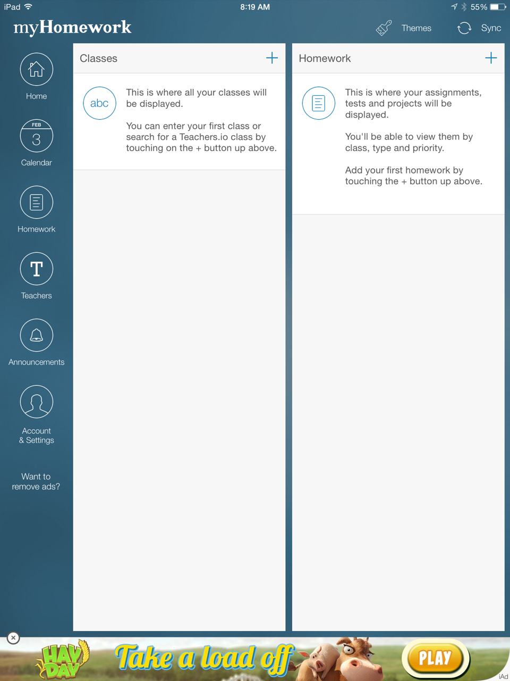
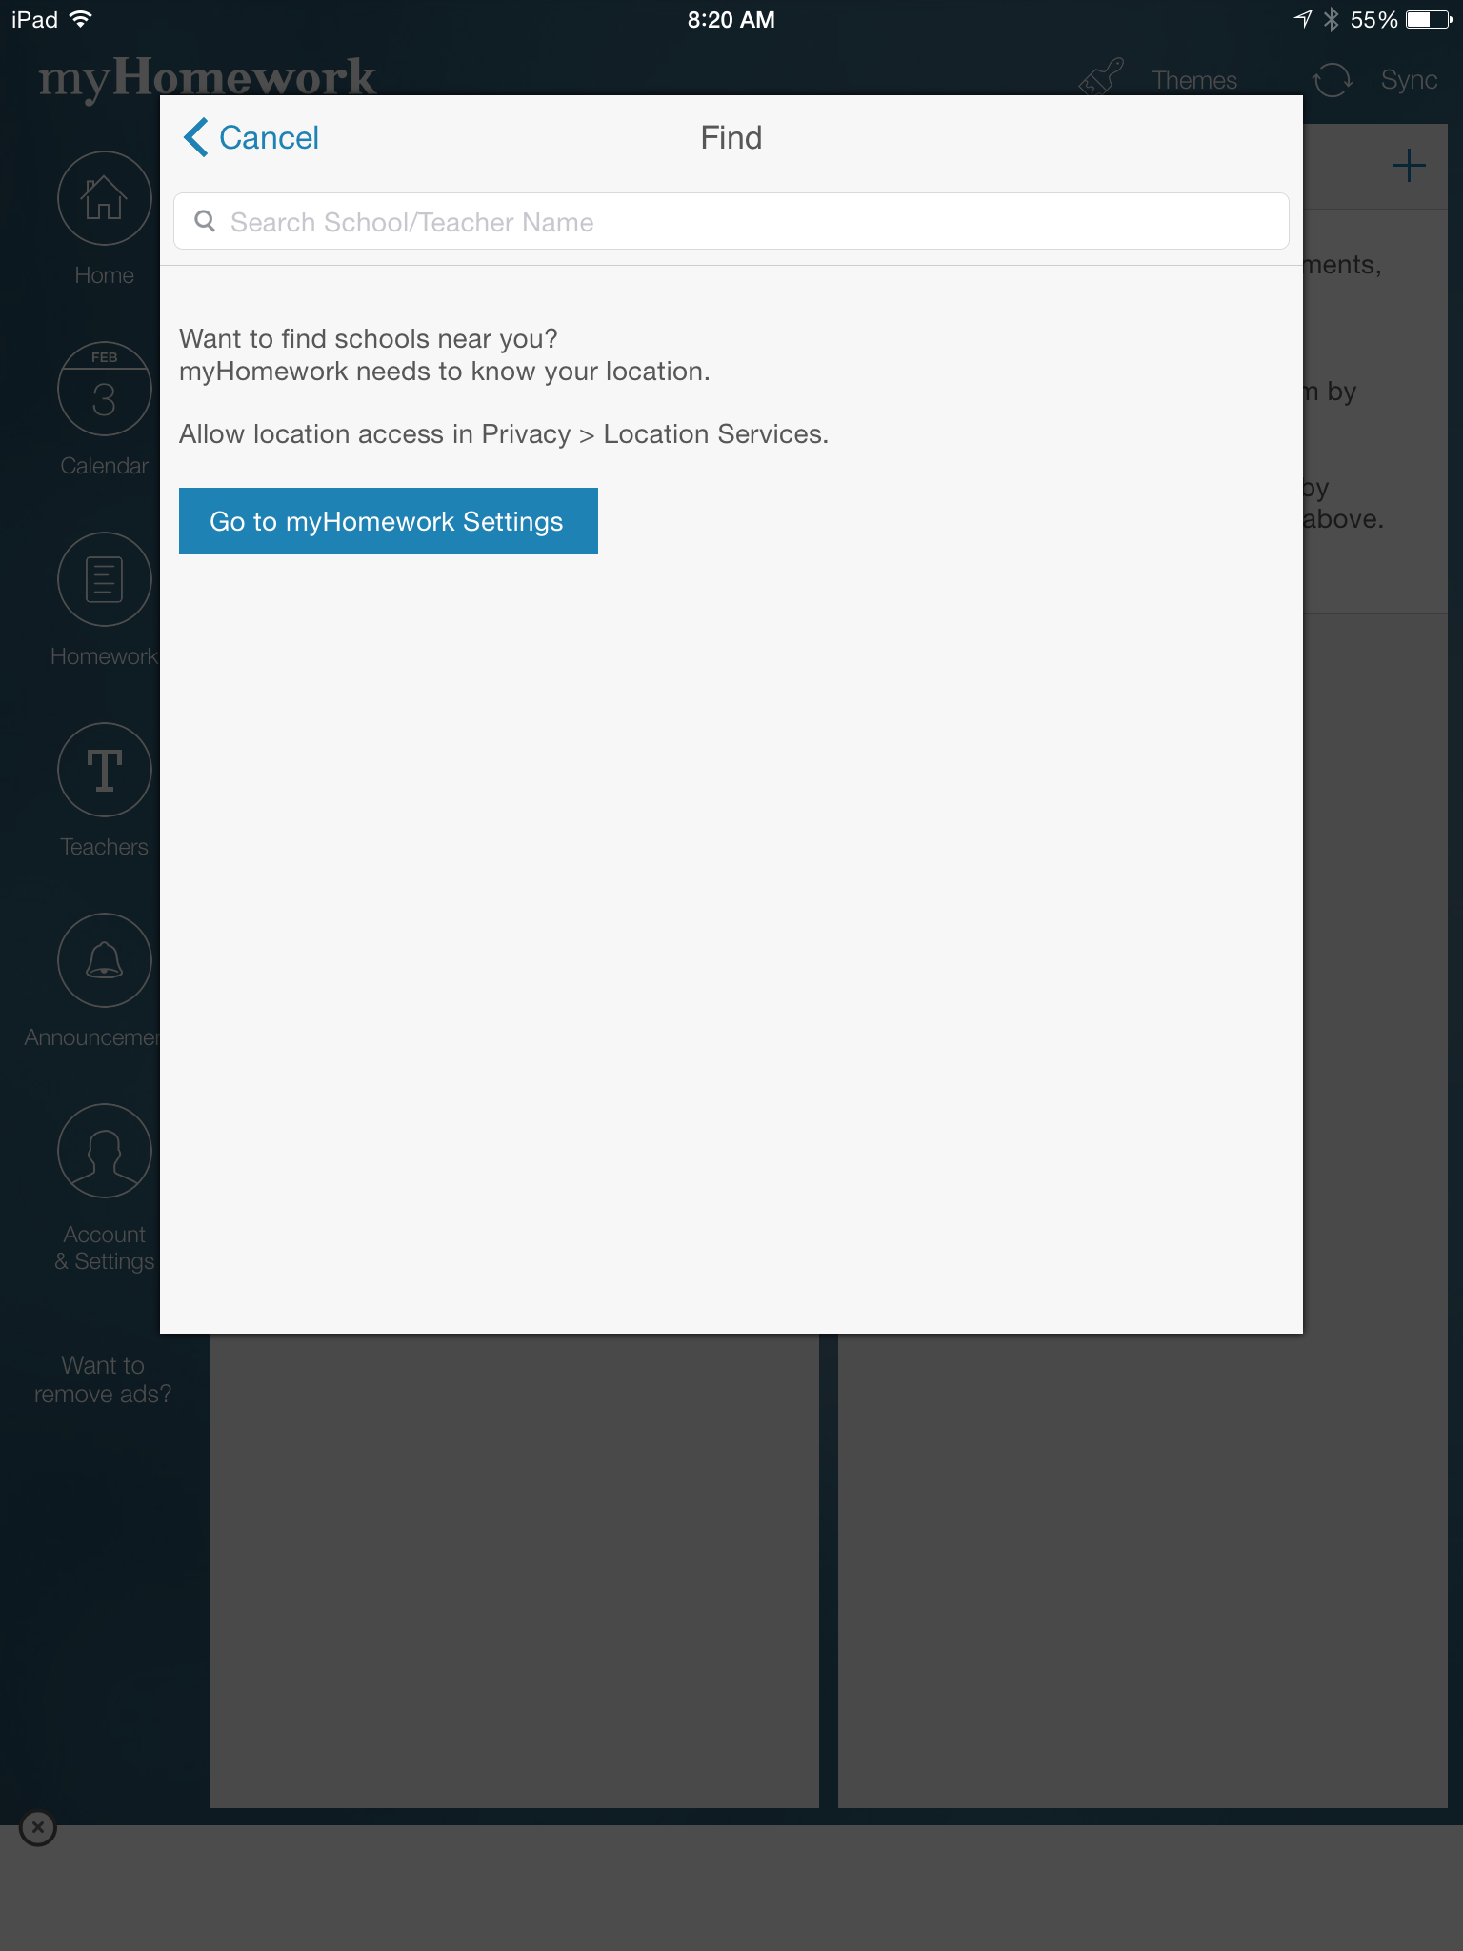
1. Create an Account

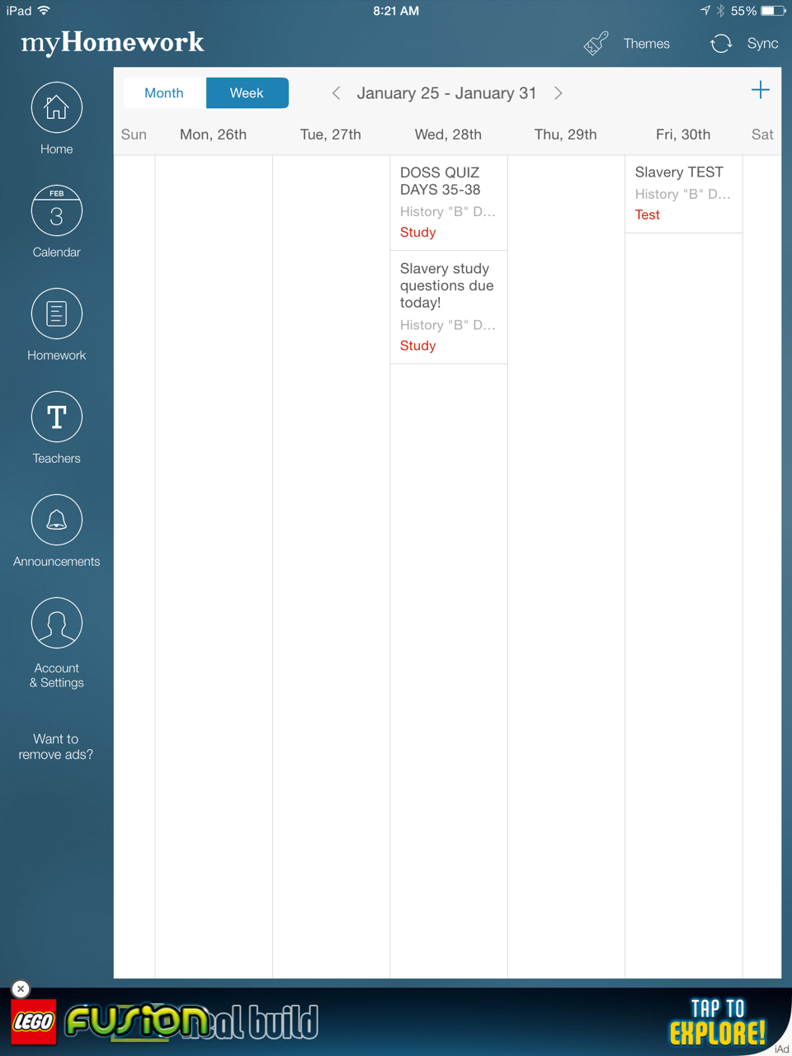
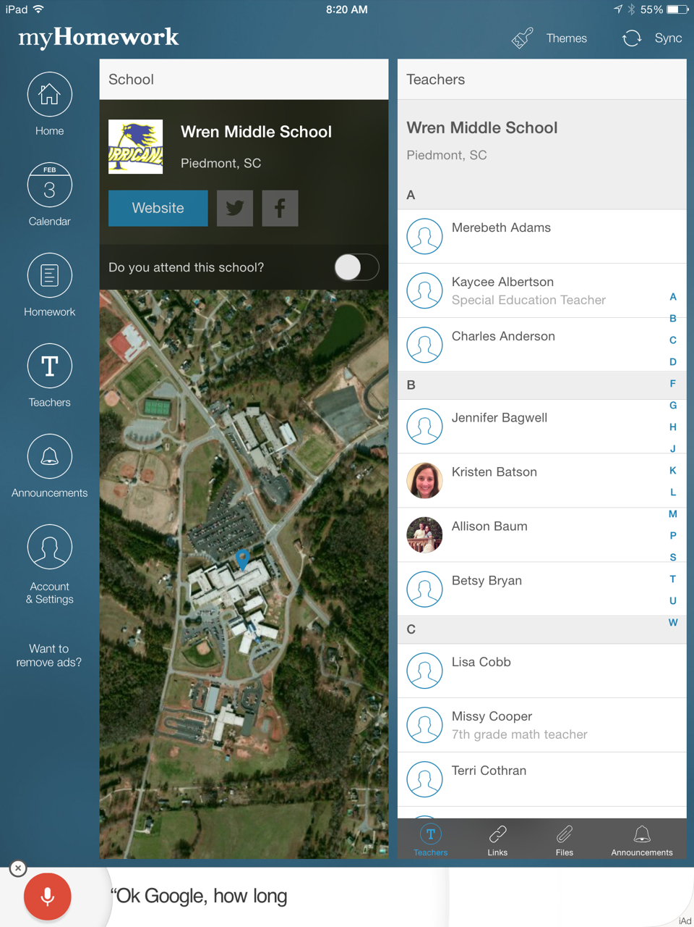
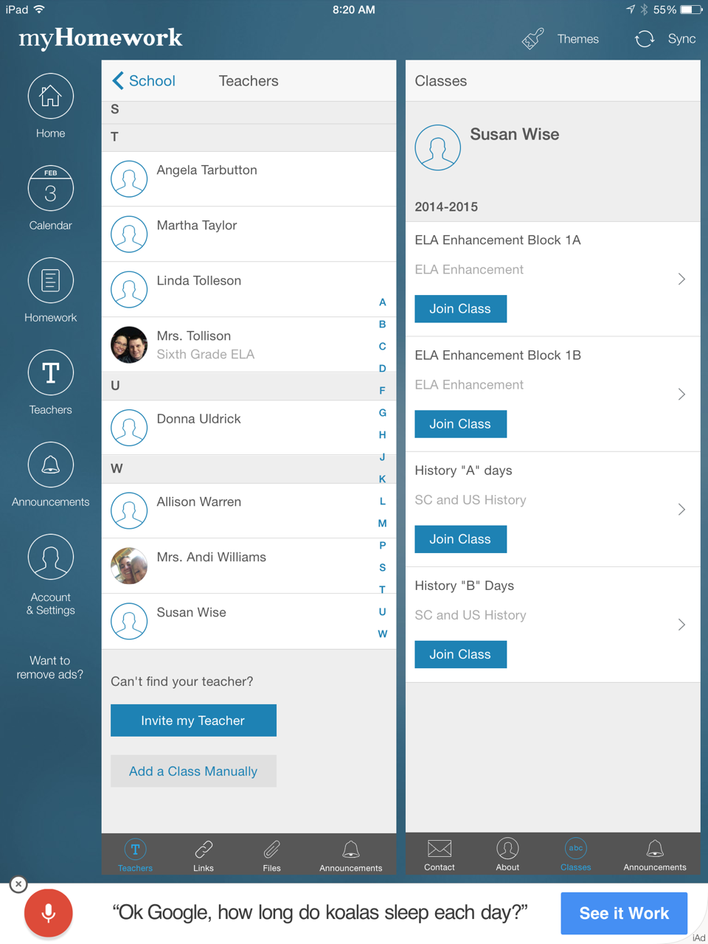
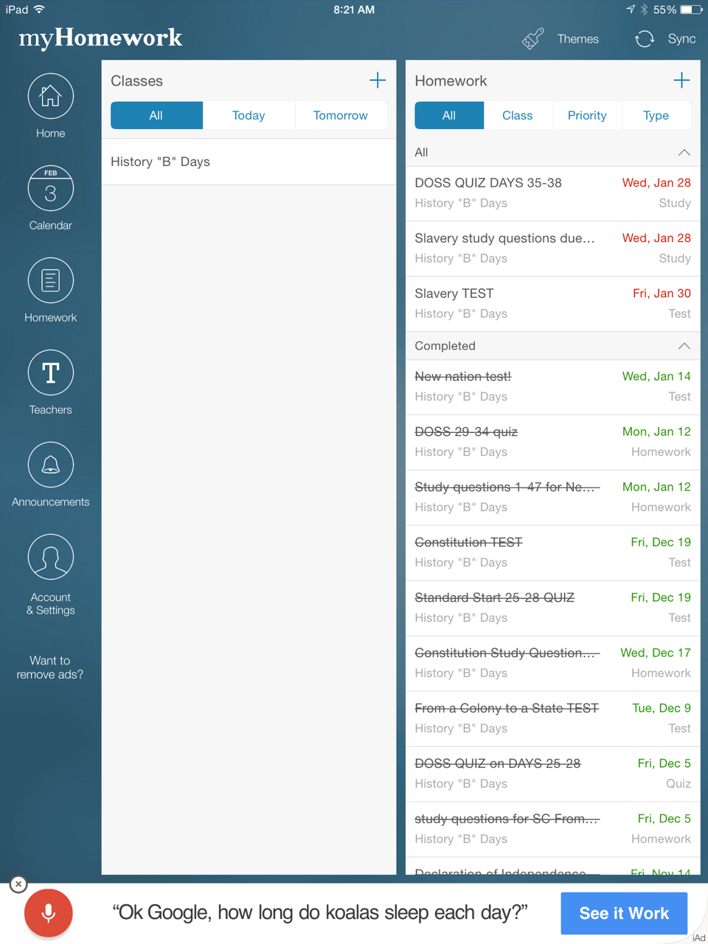
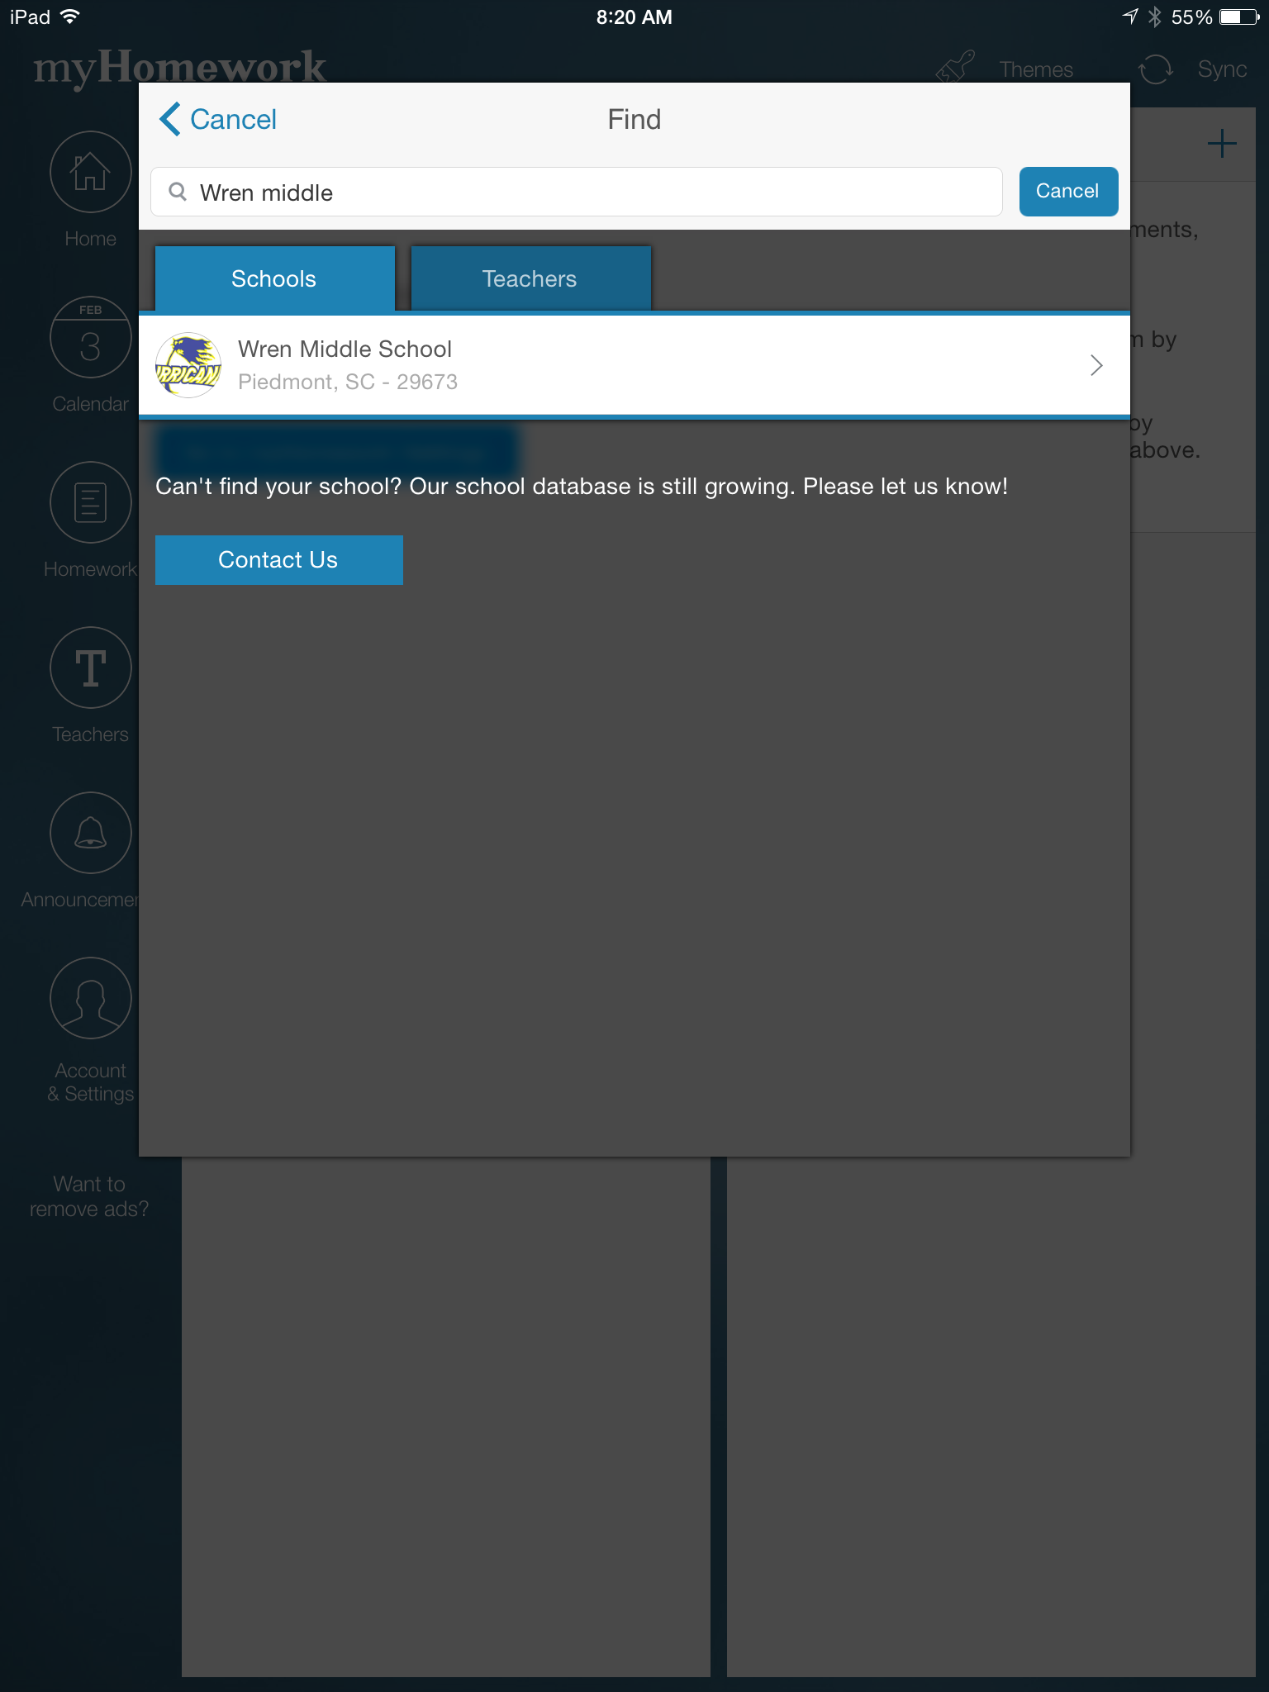
myHomework Tips

You can join multiple schools and teachers to keep track of multiple students.

You can also create an account at myHomework.com on a computer.
7. Calendar view shows you when assignments are due on the Calendar
6. View all of the Homework that has been assigned
4. Select Wren Middle
3. Type in Wren Middle and Search
2. Tap the + to add a class
5. Select the Teacher
5. Click Join Class for the correct class

